Chapter 19 - Plate Tectonics - Lab Exercises Name ____________________
Plate Tectonic exercises are in the Lab Manual by Hamblin and Howard. Read the introductory material for each exercise, then answer the following questions.
Exercise 18. Plate Tectonics
1. Draw the plate boundaries on the map below, showing the convergent boundaries in blue, and the divergent boundaries in red. Use arrows to show the direction of plate movement. Label the names of the 7 major plates on the map.
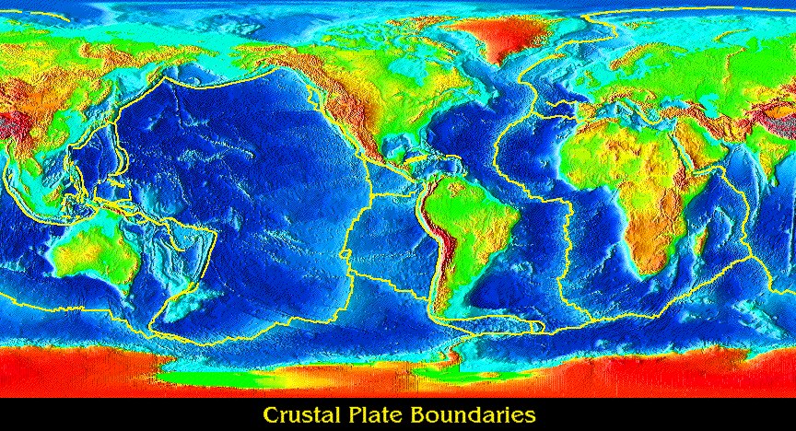
Exercise 19. Divergent Plate Boundaries
2. f. Why does the trend of the Mid-Atlantic Ridge parallel the continental margins on both sides of the Atlantic Ocean?

Exercise 21/ Conergent Plate Boundaries
Ocean-ocean convergence: Note the Tonga Trench north of New Zealand on the map at the back of the lab manual. What feature does the red line represent? ______________________ What land form is to the west (left) of that red line? ____________________________________ What geologic feature and process caused it?

Ocean-Continent convergence:
9, South America:
e. Draw a cross section across the central Andes and the adjacent deep sea trench, labeling the names of the plates and showing the directions of movement.

f. Where would deep focus earthquakes occur in South America?

Continent-Continent Convergence:
6. Alpine-Himalaya belt:
f. Why are there no deep focus earthquakes below the Himalayas?

c. What is the origin of the lowlands of the Ganges and Indus river plains in northern India and Pakistan?

22. Plumes and Hotspots
11. Snake River Plain
a. What is the direction ______________ and rate _____________ (in km/million years) of plate movement over the hotspot?
b. What area will be over the plume 10 million years from now?

